Agenda

1. NoSQL
2. MongoDB
3. CRUD, Index creation
4. CAP Theorem

Data – Information (Useful data)

1. Structured Data
2. Un-Structured Data

Database - A database is an organized collection of structured information, or data, typically stored electronically in a computer system

DBMS – Database Management System (It’s a Computer Software to store and manage the data effectively)

RDBMS – Relational Database Management System –

Lotus

Foxpro – Lang with DB Support

MS-Access

Popular RDBMS

1. Oracle XE (Express Edition)
2. MySQL (Open Source – Community Edition)
3. Postgres (Open Source – SQL/NoSQL)
4. DB2 (IBM Product)

No SQL – Not Only SQL / Non-SQL - NoSQL is a database design approach that stores and retrieves data in ways other than the tabular relations used in relational databases. NoSQL stands for "non-SQL" or "non-relational

SQL – Structured Query Language (Query based Language for managing Structured Data)

In RDBMS, everything is Entity (Table, Query, Trigger, Procedures, Functions, Sequences)

In Java, everything is Object

Popular NoSQL DB

1. MongoDB
2. Cassandra
3. DynamoDB
4. Redis
5. GraphQL

MongoDB – Document Based DB

Download URL - <https://www.mongodb.com/try/download/community>

All DB – Client Server Technology

ATLAS – Cloud Version of MongoDB

Local Installation – Community Server of MongoDB installed in the System

MongoDB Compass – It’s a GUI/CLI client to interact with MongoDB server

Different ways of Accessing Database

1. Using CLI client (Using Commands) knowledge of commands related to the RDBMS is important
2. Using GUI client (Usually provided by the DB Developers/ Generic One) – [Knowledge of SQL commands is not necessary]
3. Using any Programming Lang [C,C++,Java, Python, etc.,]

IP Address of Localhost 127.0.0.1

Default port number for MongoDB is 27017

|  |  |  |  |
| --- | --- | --- | --- |
| **Sl No** | **Database Name** | **URL** | **Default Port** |
| 1 | Oracle XE | oracle:thin://localhost:8080/apex | 8080 |
| 2 | MySQL | mysql://localhost:3306/{db_name} | 3306 |
| 3 | Postgres | postgres://localhost:5432/{db_name} | 5432 |
| 4 | MongoDB | Mongodb://localhost:27017 | 27017 |

<https://gmail.com>

mysql://localhost:3306/{db_name}

oracle:thin://localhost:8080/apex

postgres://localhost:5432/{db_name}

CRUD – Create/Insert Read Update Delete

use sapient

db.sample.find()

{

_id: ObjectId(**"65277a3e64ba513dcf4927df"**),

firstName: **'abcd'**,

lastName: **'xyz'**,

email: **'abcd.xyz@sapient.com'**,

mobile: **'9809785634'**

}

{

_id: ObjectId(**"65277b4c64ba513dcf4927e0"**),

firstName: **'mno'**,

lastName: **'pqr'**,

email: **'mno.pqr@sapient.com'**,

mobile: **'9977885522'**,

address: **'chennai'**

}

db.sample.find({firstName : "abcd"})

{

_id: ObjectId(**"65277a3e64ba513dcf4927df"**),

firstName: **'abcd'**,

lastName: **'xyz'**,

email: **'abcd.xyz@sapient.com'**,

mobile: **'9809785634'**

}

sapient

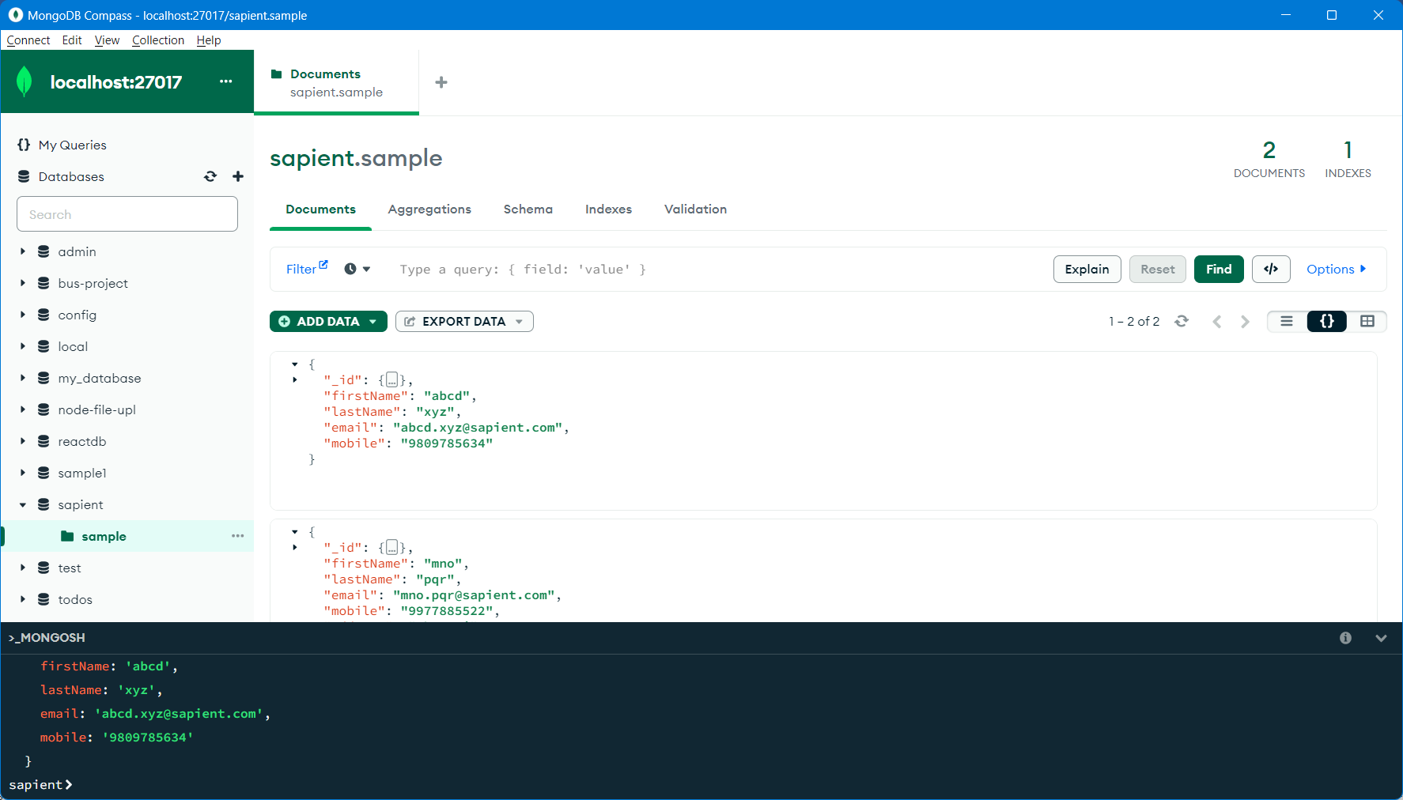

Accessing the DB using programming Lang.

JDBC – Java DataBase Connectivity API

API – Application Programming Interface

Connecting Laptop with Printer

1. Install Driver
2. Establish Connection
3. Test Print
4. Actual Print
5. Power Off

Interacting to a DB using Java JDBC Api

1. Load & Register the Driver
2. Establish the Connection
3. Create Queries to perform some operation
4. Execute & Process the Result
5. Disconnect

Download and add Mongodb driver to the Java Project

<https://mvnrepository.com/artifact/org.mongodb/mongodb-driver-sync/4.11.0>